
Magnetic Float Level Switch for Liquid Application
Model: MFLS-1300L


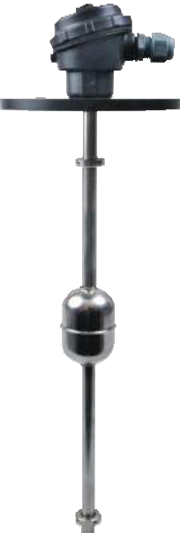
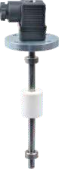
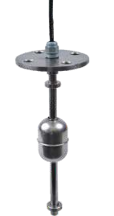
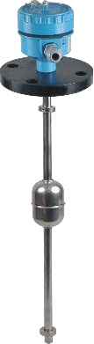

FILPRO






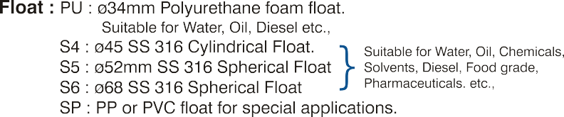
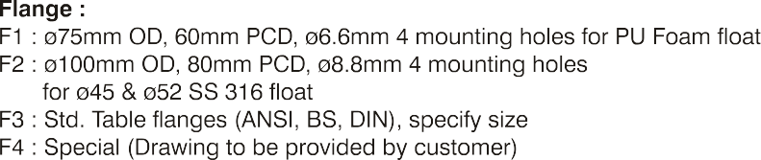
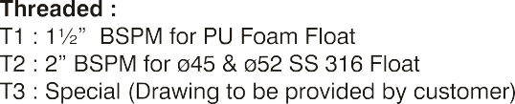

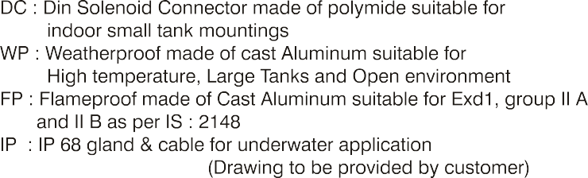

Magnetic Float Level Switch for Liquid Application
Model: MFLS-1300L











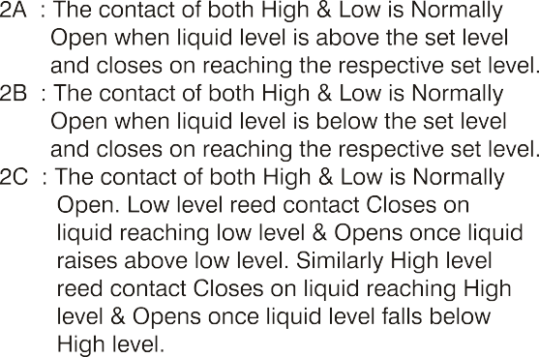
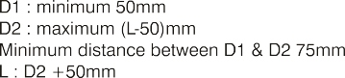
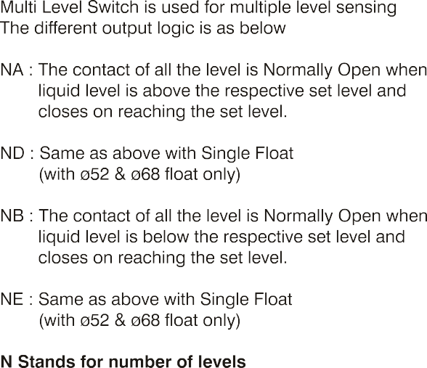







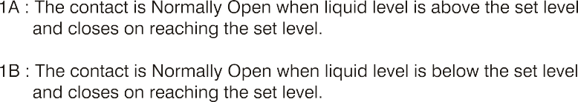
Magnetic Float Level Switch for Liquid Application
Model: MFLS-1300L









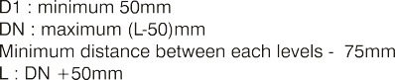

Magnetic Float Level Switch for Liquid Application
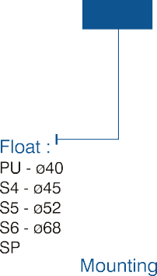
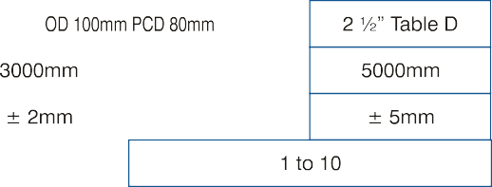
Model: MFLS-1300L

 |  |  |  | 

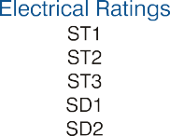
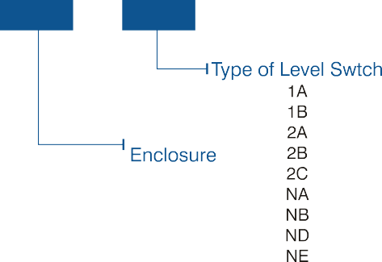
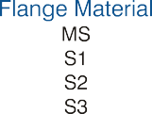

Levtron Instruments Pvt Ltd.
Office No 2, 1st floor, plot no 6,
Pandhari Industrial estate,
Shivane. Pune 411023,
Contact: 09579430012 / 9730042725
E-mail: sales@levtron.in Website : www.Levtron.in Pvt. Ltd

